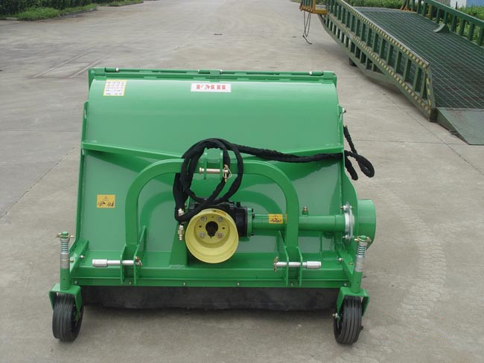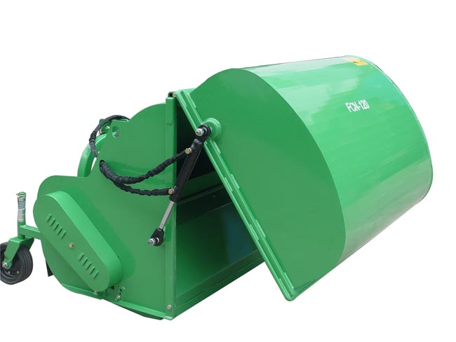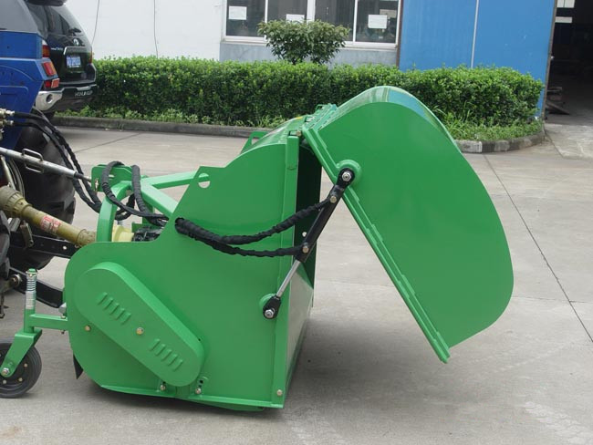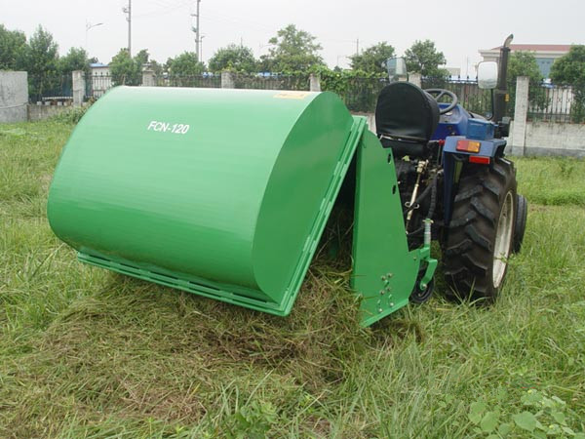

Specification
1. 50 HP Gearbox
2. Hydraulic collector opening
3. Cast-iron gear box with free wheel
4. Y blades
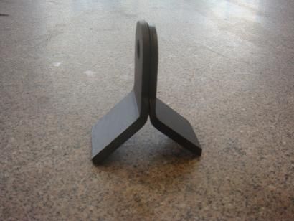
Standard ''Y'' Blade
Model | FCN120
Cutting Width | 1150mm
Capacity | 0.6m3
PTO Speed | 540rpm
Weight | 325kg
Tractor HP | 20-40hp

